**Mediterranean Shipping Company**

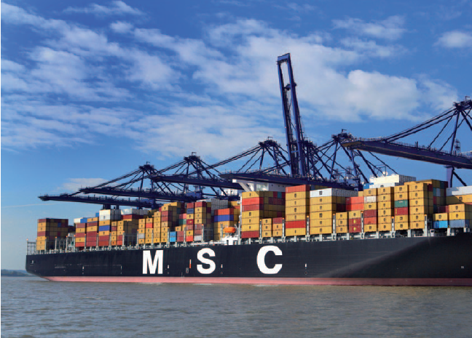

As the second-largest shipping company in the world, MSC’s (Mediterranean Shipping Company) fleet annually transports more than 12 million containers that have to be loaded and cleared in some 270 ports. Handling transport and its associated process chain is complex; it is affected by uncontrollable situations such as bad weather, strikes, etc., and it is accompanied by immense volumes of data and information: certificates of origin, documents of title to goods, way bills, bills of lading, commercial and customs invoices, and packing lists, to name but a few. The central IT system in Geneva has to electronically process and validate more than 300,000 transactions each day.

In the transportation sector, the containers and papers dictate the route and planning because, given the long supply chain, outside influences such as a strike by truck drivers, dockworkers, or customs agents, a storm, missing papers, or an error by the tracking companies, all can result in repeated changes. For this reason, a clear workflow has to be provided that can track and record the current course of the process, and when unplanned changes occur, automatically authorize consistent and logical steps. “Ship transport is just a small part of the entire transport and supply chain. But it is extremely critical. Many customers who trust us with their freight depend on precise and current delivery information for the planning of their company activities,” says Rumen Lilov, eBusiness Development Manager at MSC. “This is why it is important to us that they receive the time status for their delivery. And specifically, from when it is accepted at the port until it is delivered at its destination.”

**Key issues/problems faced by MSC:**

**Problem 1:** **Existing technologies could not meet the requirements.**

The existing database in use at MSC unable to manage the volumes of data, process and validate them in **real- time**, and make them available without delay to the MSC agency network worldwide.

**Problem 2: Existing Information Systems have no clear workflow implemented.**

**Problem 3:** **Inability to provide precise information & tracking/alerting mechanism about freight of MSC customers around the globe.**

**Your task:**

Form groups of five members.

Assume that your team has been appointed as the responsible IS/IT professional consultants by MSC to analyze the current situation in detail.

Apply your knowledge gain through the lecture session-Modern Information Systems and provide a sophisticated IS/IT solution/s for the main problems listed above. You are required to clearly understand the issues and explain how your solution resolve such issues.

Discuss the strategic/competitive advantages that MSC may achieve through your holistic solution.

Submit a Word/ PDF document of the solution you propose to the link given.

NOTE: Randomly picked few teams should present their solution in the class room.